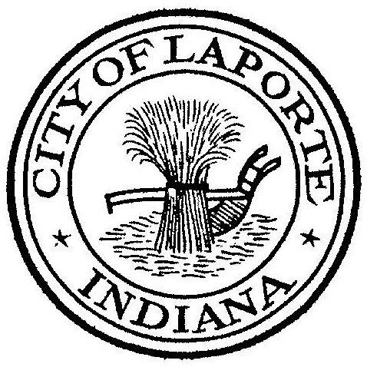
Board of Public Works and Safety
Jessica Romine, Member Tom Dermody, Mayor Mark Kosior, Member
City Hall 801 Michigan Ave., La Porte, IN 46350
Monday, October 24, 2022
9:00 AM
SPECIAL MEETING AGENDA
- Call To Order
- Pledge Of Allegiance
- Public Comment: In Person and via Facebook Live
- New Business:
-La Lumiere School v. Donda Academy Agreement
5) Unfinished Business:
6) Other Business: Next Meeting will be on Wednesday, November 9, 2022 at 9:00am due
to Election Day on Tuesday, November 8, 2022

